Name: _______________ Date: ___________

Democracy
Direct vs. Representative

What is Democracy?
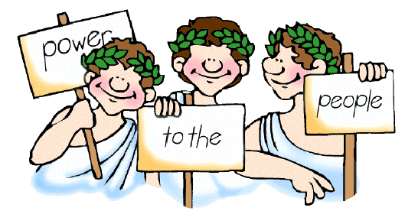
The United States of America believes in a democracy. A democracy is a form of government that allows the citizens of the country to participate equally either directly or through representatives to establish laws. Democracy was not originally develop in America. Over 2400 years ago in Athens, Greece this system of Government was developed.

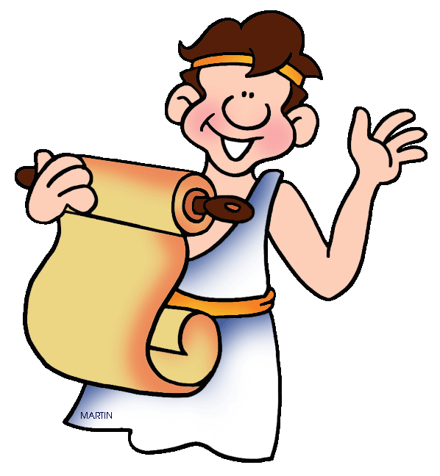
What is a Direct Democracy?
In Athens, Greece each year there was a drawing. 500 names of citizens were selected to serve in the Government for one year. Citizens were free men. Women, children, and slaves were not citizens and could not participate in the government. During this year the men would create new laws or change old laws. But, these laws were not official until every citizen of Athens, Greece voted yes or no. If the majority (most) of the citizens voted yes then the law would be enforced and if they said no then it wasn’t enforced. This form of government was known as a direct democracy. Direct Democracy was the form of government in Athens, Greece until Sparta another City-State of Greece took control over Athens.

What is a Representative Democracy?
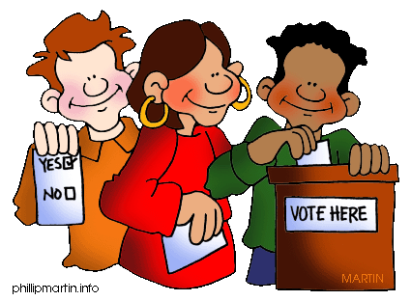
The U.S.A took Athens, Greece’s approach to government but changed it to fit our needs. Instead of having every citizen vote for every law, the American people decided to select a small group of people to represent everyone in America. These people can create and change laws without having to get the approval of all citizens. Because these people represent the needs of the many in American we call our form of democracy a representative democracy. Like Greece, America only allows citizens to vote. Years ago women and African American men and women were not allowed to vote. We still do not allow children to vote on government issues, but all men and women citizens of America have the right to vote today.
Read and answer the following questions.
- What is a direct democracy? ______________________________________________

_____________________________________________________________________

_____________________________________________________________________

- Who has a direct democracy?
  - Ancient Athens, Greece b. United States of America

- What is a representative democracy? ______________________________________

_____________________________________________________________________

_____________________________________________________________________

- Who has a representative democracy?
  - Ancient Athens, Greece b. United States of America

- Who was not allowed to vote in Ancient Athens democracy?

_____________________________________________________________________

- Who votes today in our democracy?

_____________________________________________________________________

